Asexual vs. Sexual Reproduction

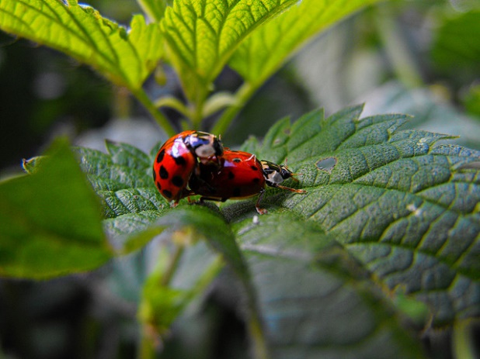
Reproduction is one of the characteristics of all living organisms. Reproduction allows organisms to create more organisms that are the same or similar to themselves. Without the ability to reproduce, species would not be able to survive. Reproduction is the process by which organisms produce offspring. There are two basic types of reproduction, sexual and asexual.

One parent or two?
That is the main difference between sexual and asexual reproduction. Sexual reproduction just means combining genetic material from two parents. Asexual reproduction produces offspring genetically identical to the one parent.

Reproduction: Asexual vs. Sexual
Cell division is how organisms grow and repair themselves. It is also how many organisms produce offspring. Cell division occurs when one cells copies its own DNA and then divides in two to create cells identical or similar to the original. For many single-celled organisms, reproduction is a similar process. The parent cell simply divides to form two daughter cells that are identical to the parent. In many other organisms, two parents are involved, and the offspring are not identical to the parents. In fact, each offspring is unique. Look at the family in Figure below. The children resemble their parents, but they are not identical to them. Instead, each has a unique combination of characteristics inherited from both parents.
Family Portrait: Mother, Daughter, Father, and Son. Children resemble their parents, but they are never identical to them. Do you know why this is the case?

Asexual Reproduction
Asexual reproduction involves a single parent. It results in offspring that are genetically identical to each other and to the parent. All prokaryotes and some eukaryotes reproduce this way. There are several different methods of asexual reproduction. They include binary fission, fragmentation, and budding. During asexual reproduction, a cell goes through division called mitosis, where two new identical cells are created.
- Binary fission occurs when a parent cell splits into two identical daughter cells of the same size as the original.
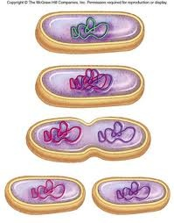
An example of organisms that reproduce this way are bacteria. In the image to the left, the original bacteria is at the top. It begins copying its DNA and then begins ‘pinching’ in half. In the end, there are two new cells that each have a copy of the DNA of the original cell.

- Fragmentation occurs when a parent organism breaks into fragments, or pieces, and each fragment develops into a new organism. Examples of organisms that reproduce this way include flatworms and starfish.
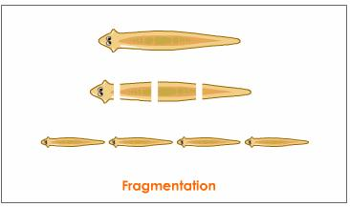
If the worm is divided, each new piece can grow into a separate organism.

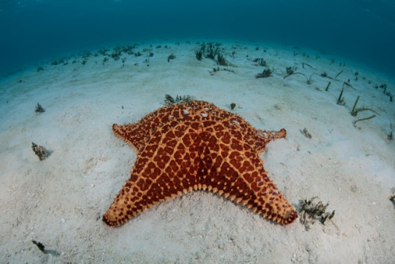

A new starfish can develop from a single ray, or arm. Starfish, however, are also capable of sexual reproduction.

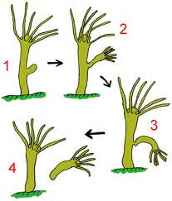
- Budding occurs when a parent cell forms a bubble-like bud. The bud stays attached to the parent cell while it grows and develops. When the bud is fully developed, it breaks away from the parent cell and forms a new organism. Examples of organisms that reproduce by budding include hydra (shown at right) and yeast.

Advantages and Disadvantages of Asexual Reproduction
Asexual reproduction can be very rapid. This is an advantage for many organisms. It allows them to crowd out other organisms that reproduce more slowly. Bacteria, for example, may divide several times per hour. Under ideal conditions, 100 bacteria can divide to produce millions of bacterial cells in just a few hours! However, most bacteria do not live under ideal conditions. If they did, the entire surface of the planet would soon be covered with them.
Another advantage of asexual reproduction is that the organisms of a species will carry on the same traits as the parents, so the species is all similar. This can also be a disadvantage. Organisms that reproduce asexually, lack diversity. Since their traits never change, these organisms do not adapt to their environment and can become extinct if their habitat changes.

Sexual Reproduction
Sexual reproduction involves two parents. The parents each produce special cells used for reproduction called gametes. The cell division process of meiosis creates these special cells. Males produce games called sperm and females produce gametes called eggs. These cells are different from all other cells in the body in that they only have half as many genes. This difference is an important one. During reproduction, the male’s sperm and the female’s egg combine in a process called fertilization. During fertilization the genes from the male and the genes from the female combine to make a complete set of genes for the new offspring in a new cell called a zygote. The zygote now has a complete set of genes that combine the traits of both parents in a unique way. Zygotes will then continue to develop into the multicellular organism it is designed to be.

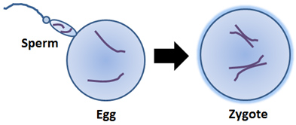
Examples of organisms that reproduce through sexual reproduction include most animals and plants. When organisms reproduce sexually, each of their offspring have different combinations of the parents’ genes, which causes siblings to appear different from each other.

Advantages and Disadvantages of Sexual Reproduction
Organisms that reproduce through sexual reproduction have genetic diversity, meaning the offspring are slightly different from the parents. This variation can allow a species to adapt to changes in its environment over time. Members of a species with weak traits are less likely to reproduce, so these weak traits are less likely to be passed on to new members and could eventually disappear in a species.
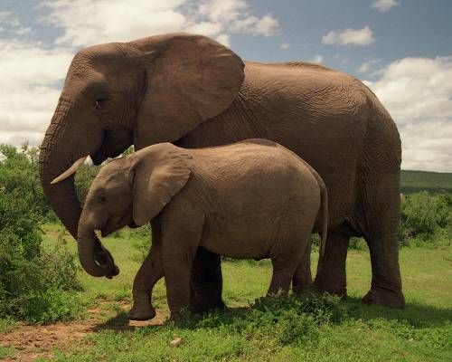
A disadvantage of sexual reproduction is that it takes a long time to produce offspring. Some organisms such as elephants take up to 2 years to produce offspring. Humans, of course, take about 9 months. These long pregnancies make it difficult to increase the numbers of a species if they are close to extinction.

Another disadvantage is since traits are randomly passed on from the two parents, sometimes favorable traits are not passed on to the offspring. For example: A father carries a gene that prevents him from getting a disease called Hanson’s disease. Only have of the father’s genes will be used to create the sperm cell and it’s possible that this disease-fighting gene might not get included. Therefore, the offspring might not benefit from this helpful gene that can prevent them from getting sick. The good news is that Hanson’s disease is pretty rare in most parts of the world.
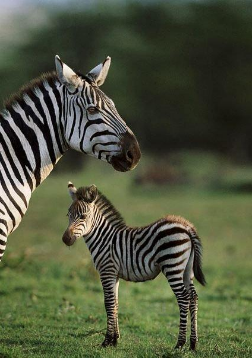
Remember, offspring created through sexual reproduction receive half of their genes (sections of DNA) from each parent. They are unique and not completely similar to either parent or any of their siblings.

