Girl Born With Eight Limbs Thrives in India
By BOB BROWN
June 13, 2008— http://abcnews.go.com

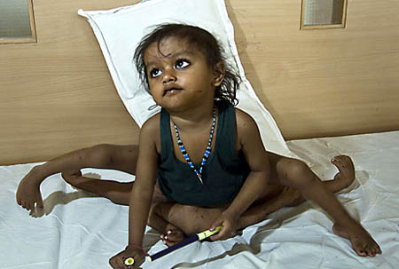
In a remote village in the Bihar region of northeast India, in October 2005, a woman named Poonam Tatma gave birth to an extraordinary child -- a girl with four arms and four legs who was destined to become famous worldwide.

The newborn was the image of a multi-limbed Hindu goddess named Lakshmi, who is worshiped as a deity of wealth and good fortune. And so the child was also named Lakshmi. "After she was born, for a whole month crowds of people came to see her," Tatma said. "It was said that Lakshmi had been born here."

Goddess or Medical Marvel?

When Lakshmi turned age 2, a social worker sent photos of her to Dr. Sharan Patil, who is a leading orthopedic surgeon at Sparsh Hospital in Bangalore, India, which specializes in treating skeletal abnormalities in children. "I had never seen anything like those pictures," Patil said. "We had read about it in our books, and medically, it was fascinating because it was such a rare thing." The doctor also knew that the child had come to be revered by many villagers. "They thought she was very special," Patil said. "She was a godsend; she was a reincarnation. They almost worshiped her in the village." Rajesh Kumar Singh, the village chief, told National Geographic that "A child who looks like this, with four arms and four legs, according to our scriptures, must be the Goddess Lakshmi. It's a wonderful piece of luck to have a child born like this and surviving like this."
How do the religious beliefs of others complicate the situation with Lakshmi?

The Tatma family earned the equivalent of about $200 a year from farming, and couldn't afford even basic medicines for Lakshmi. They could have profited by charging others to see her, but chose not to. They turned down an offer to sell her to a traveling circus. Her parents, too, believed she was a goddess. But they also knew she had the needs of a disabled child. Her mother worried about how she would provide care when Lakshmi grew older. "Picking her up, sitting her down, putting her to sleep, these are the problems," Poonam Tatma said. "She tries to crawl with other children but they go ahead of her. She can't keep up. The problem is what will happen when she is older? Right now, she is small, so we can do it. When she is older, who will do it?"

Determined to study the child, Patil went on a journey to the remote Araria district in Bihar to meet Lakshmi and her family. His arrival in the village caused a stir. Cars are rarely seen in Bihar. Patil approached the Tatma family gently by asking if he could conduct examine Lakshmi. "I think the past experience of the parents, of reaching out to the doctors, was that the circumstances were probably not right. They had had bad experience in the past. So they had their reservations to start with. They were wondering if we had some ulterior motives toward them." What Patil discovered is that the child that many associated with the image of a goddess was, in fact, a case so rare that only a few have been known in history.

Lakshmi had two arms and two legs that functioned normally (they were the uppermost limbs on each side of her body). Below those limbs, in mirror image, were two more sets of arms and legs. The lower part of Lakshmi's body was a type of conjoined twin called a parasitic twin. "One of the babies is alive, but the other baby doesn't exist as an individual," Patil said. "The two bodies are fused together. The entire parasitic part of Lakshmi's body was feeding on Lakshmi for nutrition, for oxygen, for energy, for everything else. That's typically how a parasite is described … a parasite which is dependent on the host." Because of the parasite, Lakshmi's health and possibly her survival were in danger. Patil believed the parasitic twin should be surgically removed. Without surgery, Patil estimated that Lakshmi's chances of surviving past her teenage years were minimal. But in Lakshmi's case, he faced something more than a medical issue. A local fair to celebrate the holy day of the goddess Lakshmi coincided with Patil's visit. Once the little girl who was the image of Lakshmi entered the crowd, it was clear that she had a profound effect on the villagers. "She was thought to be bringing a lot of good things to the village and the people around," Patil said. "Some of them even folded their hands in respect for the little girl, which was quite amazing." Because she was considered a good omen to the village, Patil worried that some villagers might be against surgery to change her form into that of a typical 2-year-old. "I'm sure a lot of the people in the village had those ideas in their minds, that if something was done to Lakshmi, things might turn around, and things might not be so good for them anymore," Patil said.
What is a parasitic twin?

Why did the twin affect Lakshmi’s health?

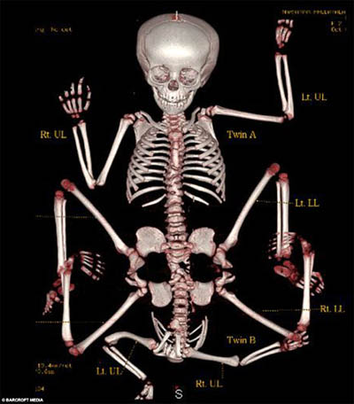
To reassure the parents, Patil arranged for all of the family's medical expenses to be paid through his hospital. Recognizing that medical care is out of the reach of millions of people in India, Sparsh Hospital in Bangalore has a foundation whose mission is to extend orthopedic and reconstructive surgical care to those who need it, regardless of income. Every day was different for the Tatma family because of fluctuations in Lakshmi's health. "So she really was living on the edge," Patil said. Having weighed their options carefully, Lakshmi's parents finally decided to travel more than 1,000 miles from their village to Sparsh Hospital, a state-of-the-art facility where doctors performed a battery of tests to see whether surgery was even possible. The first X-rays revealed complications. Lakshmi's spine was joined to that of her parasitic twin, and doctors had to determine how to separate the spine without affecting Lakshmi neurologically. They also discovered that Lakshmi had only one functioning kidney. A second functioning kidney was in the parasitic twin. "The team itself [included] 37 people as part of the surgical procedure," Patil said. "We had five sets of surgeons who operated on the little girl."
What do you feel the role of any government should be in paying for the citizens’ healthcare?
Draw a line through the x-ray where the twins are joined.

Surgery Day

On Nov. 6, 2007, Lakshmi was wheeled away from her parents, and the surgery began. Pediatric surgeons made the first incision, to identify her internal structures -- "which of them belonged to the parasite and which belonged to Lakshmi," Patil said. Surgeons tied off connecting blood vessels, ensuring that Lakshmi's vital organs weren't damaged. After the parasite's functioning kidney was transplanted to Lakshmi, neurosurgeons began the dangerous separation of Lakshmi's spine where it was connected to the spine of the parasite. "One [couldn't] make out where the spine of Lakshmi ended and then the other one started," Patil said. "So we erred on the side of safety, and preserved some part of the spine of the parasite." At midnight, 16 hours into the operation, came the riskiest surgery of all. Doctors were finally ready to remove Lakshmi's conjoined, parasitic twin. "It was a very critical and crucial phase because there were a lot of body fluid shifts, and the moment we tie off the blood vessels, there is a buildup of chemicals in the parasitic twin, which can become dangerous if they travel back into the host tissue. So we had to be pretty quick from that point on. Speed was of the essence at that point in time." Another crucial phase in the reconstructive surgery was to bring the bones of Lakshmi's pelvis together so that they could support her vital organs.
What are at least three complications the surgeons had to deal with during the operation to separate the twins?
1. 2. 3.

After the Surgery

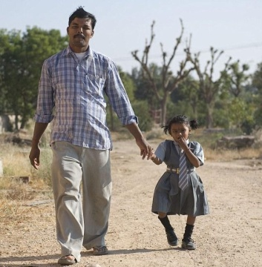
Twenty-four hours after the surgery began, Patil finally was able to reassure Lakshmi's parents. "The operation was successful," he told them. "Lakshmi is healthy." In her room, recovering from the surgery after sleeping soundly, Lakshmi began to open her eyes and move her fingers. For the first time, her parents saw the child who once had been the image of a goddess as an average 2-year-old, with two arms and two legs. "Lakshmi had one strange look on her face, looking down at her own body," Patil said. "I don't know how to put it but … I almost felt that she was telling me, 'Doc, good job done.'" When Lakshmi was released from the hospital a month after the surgery, the family took her to the desert state of Rajasthan, far from their village, where she began attending a school for disabled children. During a school break, they returned to their village for a visit. Lakshmi is learning to raise herself upright and balance herself. She has begun to take her first steps. "Now she can walk on her own," her mother said. "Her cousin comes, and they play the whole day long."

Lakshmi will need additional surgery where her spine was separated from her parasitic twin. She also will need surgery on her feet, which were turned inward because of their positioning above the area where she was joined to the parasite. A statue of Lakshmi, made by a village craftsman when she still had eight limbs, remains in the village. Some villagers told interviewers they still consider Lakshmi a goddess. Certainly, her parents do. "I think for every parent the child is a goddess," Patil said.
Evaluate: What are the pros and cons to performing surgery on people with physical deformities?
Pro:

Con:

Apply: How might this story be different if Lakshmi was born in the U.S.?

Evaluate: What are your thoughts on society providing medical care for those who cannot afford it?

What is to be gained or lost by providing free operations to those who are less fortunate?

