Name _________________ Date______________ Core _______ Page_______

Directions:
- Label: Right Ventricle, Left Ventricle, Right Atrium, Left Atrium, Superior Vena Cava, Inferior Vena Cava, Pulmonary Artery, Pulmonary Veins.
- Color all VEINS Blue and All ARTERIES Red.

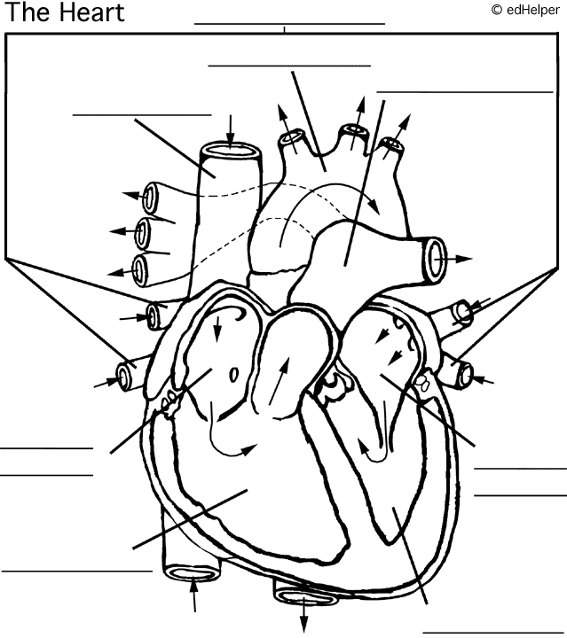

Name _________________ Date______________ Core _______ Page_______

Directions:
- Label: Right Ventricle, Left Ventricle, Right Atrium, Left Atrium, Superior Vena Cava, Inferior Vena Cava, Pulmonary Artery, Pulmonary Veins.
- Color all VEINS Blue and All ARTERIES Red.

