Forecasting Weather
Directions: Over the course of 4 days, you will track weather fronts and air masses in the United States. Using colored pencils, draw the fronts in the US along with the high and low pressure systems using the correct colors. You will also make predictions as to how the weather systems will change for the next day.

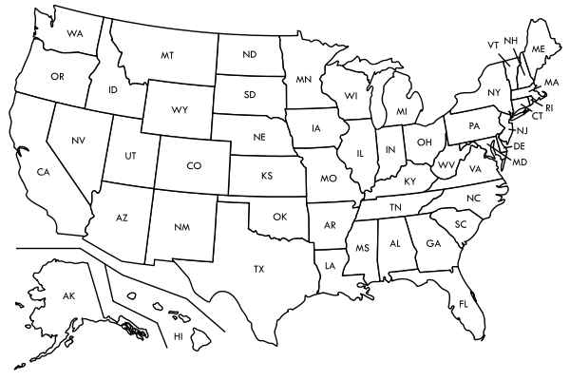

Describe what is happening above.

Make a prediction: How do you think the systems will move for tomorrow? What areas could expect rain? What areas should expect nice weather?

---------------------------------------------------------------------------------------------------------------------------------

Describe what is happening above.

Make a prediction: How do you think the systems will move for tomorrow? What areas could expect rain? What areas should expect nice weather?

