Introduction to Genetics Webquest
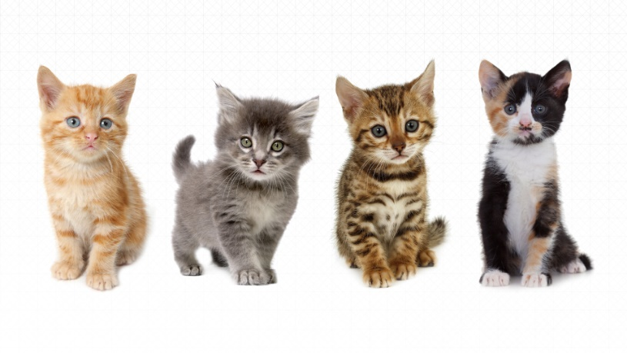
2. Until around 1900, most people thought that it was a matter of chance if you received a particular physical trait, such as long hair. What other traits besides physical (ones that you can see) are passed on from parent to offspring (children)?
1. Using the cats to the left, list all the physical characteristics that may be different amongst these cats or other cats.

3. A purebred cat is one where an owner knows the parents for at least five generations. Draw a diagram to figure out how many cats that involves.

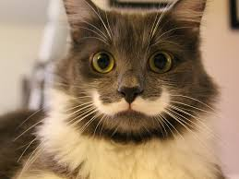Fluffy the Purebred cat
|
|
Generation 1: Parents

Generation 2: Grandparents

Generation 3:

Generation 4:

Generation 5:

-----------------------------------------------------------------------------------------------------------------------------------
Use the following sites to answer the questions below:
http://www.ducksters.com/science/biology/mendel_and_inheritance.php
http://web.pdx.edu/~cruzan/Kid's%20Mendel%20Web/Menu.htm
http://kidshealth.org/en/parents/about-genetics.html
http://kidshealth.org/en/kids/what-is-gene.html

4. Write a brief summary of Gregor Mendel’s biography.

5. What are reasons why Mendel wanted to study pea plants?

6. Define trait:

7. Define genetics:

8. What were the results when Mendel crossed only short plants?

9. What were the results when Mendel crossed true breeding tall plants?

10. Define genes:

Watch the following video: https://www.youtube.com/watch?v=cWt1RFnWNzk
(there is a lot here that we will get to throughout this unit)

11. What is F1 and F2?

12. Mendel used the terms _______________ and recessive to describe the “strength” of genes.

13. How are dominant and recessive traits represented with symbols?

14. A true-breeding tall plant will have the symbol __________.

15. A hybrid plant will have the symbol __________.

Using the space below, make a visual of the results of Mendel’s experiments.

