Background Information
Heredity is the passing of traits, or characteristics, from parent to offspring. The units of heredity are called genes. Genes are found on the chromosomes in the cell. The combinations of genes for each trait occurs by chance.
When one gene in a gene pair is stronger than the other gene, the trait of the second gene is masked, or hidden. The stronger gene is the dominant gene. The gene that is masked or covered up is the recessive gene. Dominant genes are written as capital letters and recessive genes are written as lowercase letters. If both genes in a gene pair are the same, the trait is said to be pure or purebred. If the genes are not similar, the trait is said to be hybrid. Sometimes genes can be neither dominant nor recessive. The result of such a situation is incomplete dominance.
The genetic makeup of an individual is kown as its genotype. The observable physical characteristics of an individual that are based on its genotype are known as its phenotype. In humans, the sex of an individual is determined by the male gene. Individuals who have two X chromosomes (XX) are females, whereas individuals with an X and a Y chromosome (XY) are males.
In this investigation you will observe how the results of different gene combinations produce certain traits.

Problem
How are traits inherited?
Materials
3 textbooks/notebooks
2 coins
Procedure
- Place the textbooks/notebooks on the table to form a wall or triangular well in which to toss the coins.
- Determine which partner will toss for the female gene and which will toss for the male gene. Remember that there are two genes per trait.
- Have the partner who is representing the male gene flip a coin into the well to determine the sex of the offspring. If the coin lands heads up, the offspring is a female. If the coin lands tails up, the offspring is a male. Record the sex of the offspring in Observations.
- For all the coin tosses you will now make, heads will represent the dominant gene and tails will represent the recessive gene.
- You and your partner should now flip your coins into the well at the same time. Note: The coins should be flipped only once for each trait.
- Continue to flip the coins for each trait listed in the table. After each flip, record the trait of your offspring by placeing a check in the appropriate box in the following table.
- Using the recorded traits, draw the facial features for your offsring in the space provided in the Observations.

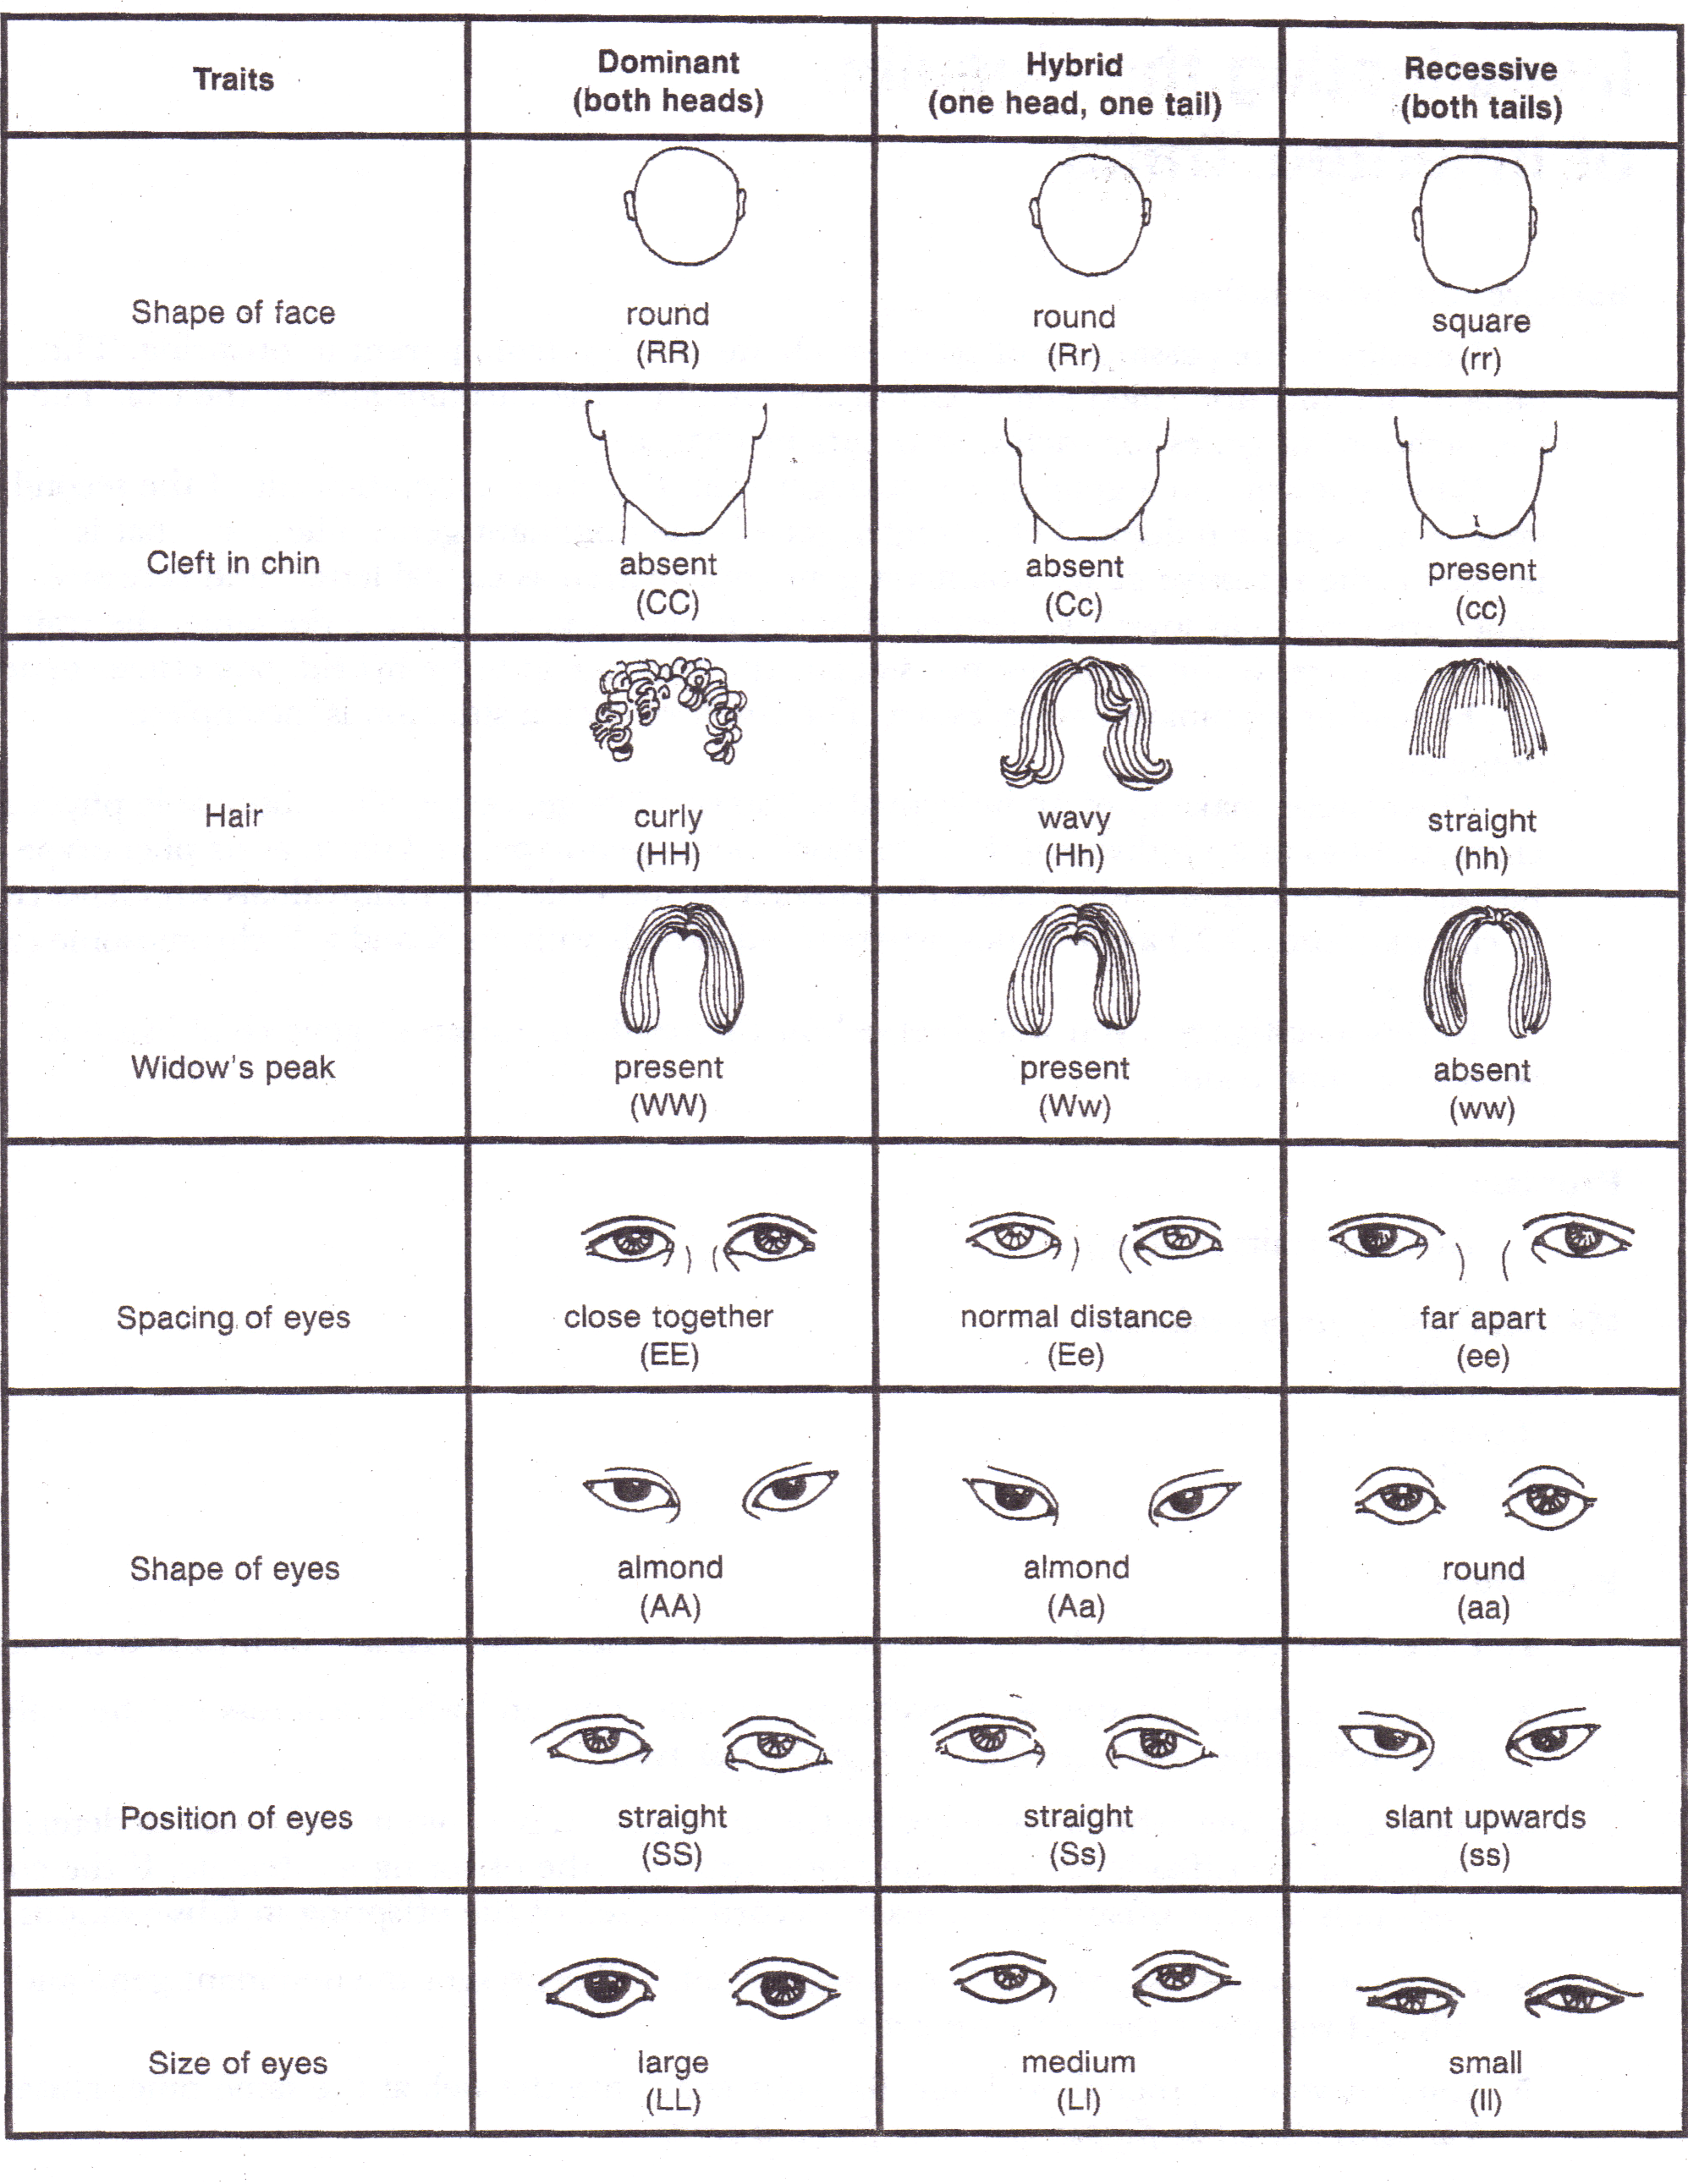
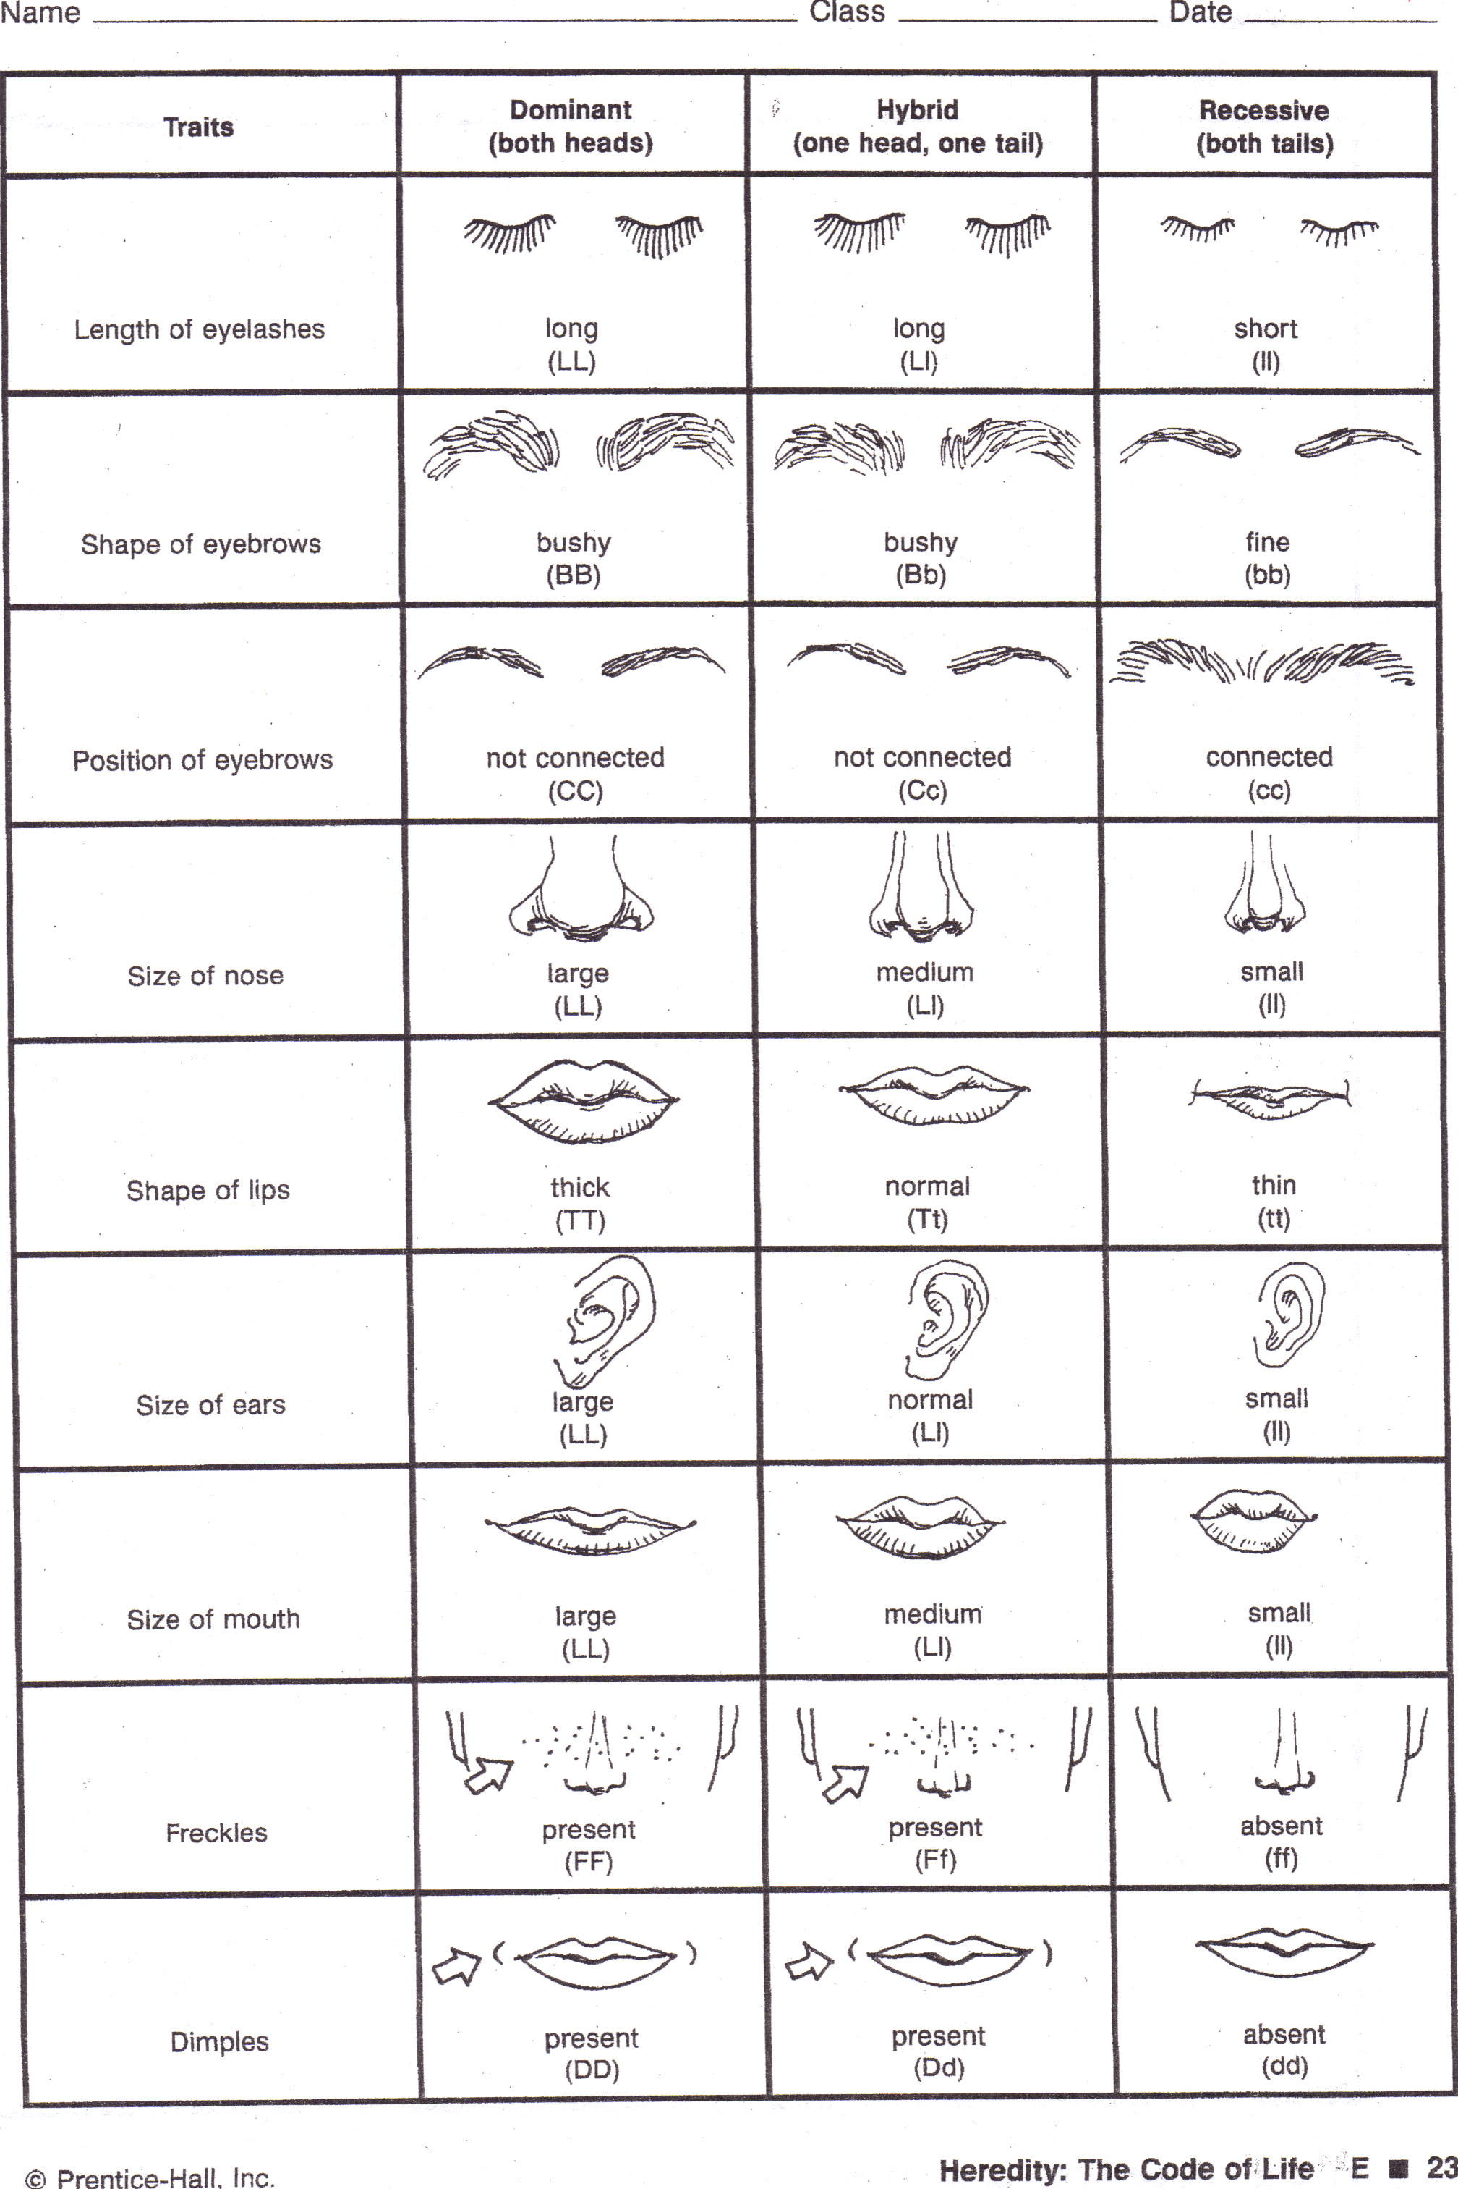

Questions: Answer in complete sentences.
- Why did you have to flip two coins for each trait?

- What percent of the genes for the offspring came from the mother? …from the father?

- In your opinion, are dominant traits more ‘good-looking’? Why or why not?

- Why is it only the male that can determine the sex of the offspring?

- Did the parent in your answer to question #4 get to pick the sex of the offspring?

- Why do you think we used a coin to represent which gene was passed on to the offspring?

- What are alleles? Pick one trait from this activity and list the alleles.

- In the background, you are told that gene combinations are random. What is meant by this?

- What was the most important knowledge you come away from the lab with?

- If an offspring inherited a dominant gene from their father who had brown eyes (B) and a recessive gene from their mother who had blue eyes (b). Give the genotype and phenotype for the offspring.

