Lab: Comparing Animal Cells
Part II
A human being is a very complex organism with a highly organized structure. Every part of a human’s body is designed to function in a certain way. In this investigation, you will examine a variety of cells that come from different parts of a human body. You will compare and contrast between each of the cells to assess how form fits function and see how these cells combine to make a variety of human tissues, organs, and organ systems.
Materials:

Colored pencils
Image—human blood
Image—frog blood
Image—motor nerve
Image—striated muscle
Image—artery and vein

Form Fits Function

BLOOD CELLS
Step 1 View the human blood image. You may see different types of cells, draw 6-7 of the most common cells you see. Try to draw it the same size as you see it. Do the exact same for one of the frog blood cells.
______________, _____X
Step 2 Examine the two cells you drew above. Describe the most obvious differences between human and frog blood. Why do you think these differences exist?
______________, _____X

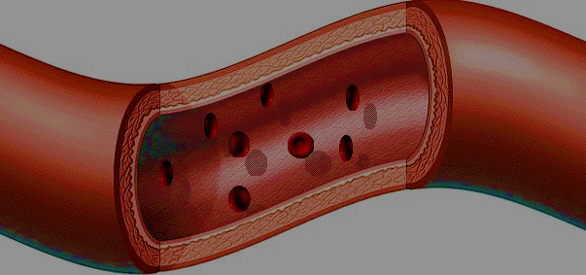
Step 3 Red blood cells carry oxygen to and carbon dioxide away from every cell in the human body via the circulatory system. The circulatory system is like a complex highway of blood vessels that range in size. All blood vessels are tube-like (see image) and some are so small they can only be seen with a microscope. How does the design of a red blood cell match its function?
MOTOR NERVE CELLS
Step 4 Nerve cells, also called neurons, are designed to carry messages throughout the body. Look at the motor nerve image.
Step 5 Examine the diagram below of a neuron to familiarize yourself with its parts.
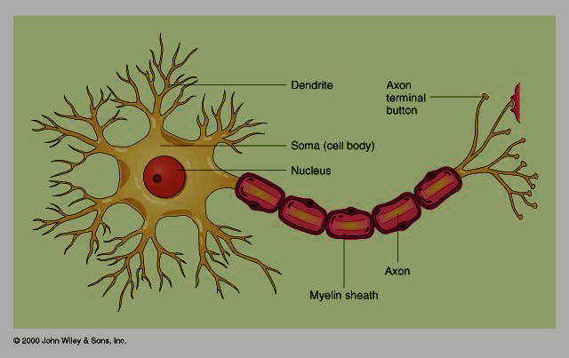
- What cell parts can you see and identify under high power?

- Why do you suppose the neuron has these long branching parts?

- How does the neuron compare to the animal cells you already observed?

MUSCLE CELLS
Step 7 Examine the image of striated muscle. There are two main parts that you should see, nuclei and striations (stripes). Wiggle your index finger up and down. The reason you are able to do that is because millions of striated muscle cells are contracting and expanding to pull your bones into the positions you want them to be in.
- After examining the muscle cells, explain why they are long and narrow and have these striations.

Step 8 An organelle important to all cells is the mitochondrion. Mitochondria are too small to be seen using only 400X, but there are many more mitochondria found in muscle cells than any other cell.
Why do you suppose muscle cells require more mitochondria?

Summary
You have just observed a variety of cells from the human body. They are all different types of animal cells.
- How are animal cells alike?

- List some ways that animal cells are different.

- Why do these differences exist?

