Name ___________________________ Date _____________ Core ____ Tk. ____ Pg. ________

Use the following link to help you complete this handout (you can find the link on the science webpage): http://water.usgs.gov/edu/watercycle-kids-adv.html
Water Cycle
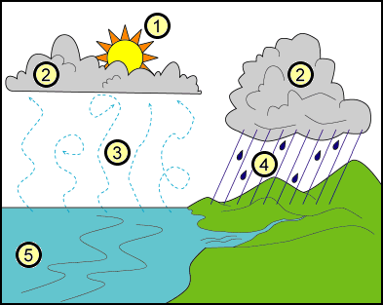

6

*3, 4, and 6 are the different phases
Label:
1) 4)

2) 5)

3) 6)

Phase | What is it? | What makes water go through this phase? | Why is it important? | What state of matter?  Example: liquid to a gas | Sketch a picture has to do with the phase.
Evaporation

Condensation

Precipitation

