Mutations
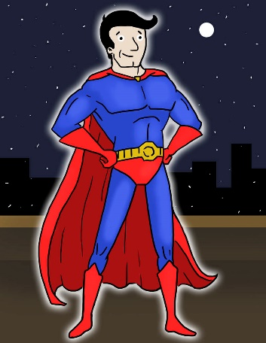
Would a mutation make you a superhero?
In the comic books, a mutation can give a person superpowers. Do you think this really happens? In real life, a mutation can be beneficial, or it can harm an organism. For example, beneficial mutations lead to evolution, and harmful mutations can lead to diseases like cancer. A mutation, however, is not going to turn you into a superhero!

Mutations
Mutation is a natural process that changes the order of the DNA chain. And it is more common than you may think. As a cell copies its DNA before dividing, a "typo" occurs every 100,000 or so links in the DNA strand. That's about 120,000 typos each time one of our cells divides. When these changes become permanent, they are known as mutations. A permanent change in the sequence, or order, of DNA is known as a mutation.
Nucleotide Bases in DNA

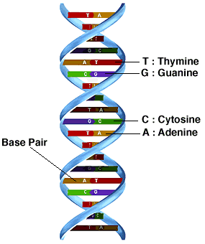
The links of the DNA chain are nucleotide bases, which are the small building blocks that make up the DNA strand. The order of these nucleotide bases determines which genes you have and ultimately decides how you will look, grow, behave, and change over time.
Most commonly, a single base is substituted for another. Sometimes a base is deleted or an extra base is added. Fortunately, the cell is able to repair most of these changes. When a DNA change remains unrepaired in a cell that will become an egg or a sperm, it is passed down to offspring. Thanks to mutation, we all have some new variations that were not present in our parents.
Effects of Mutations
People commonly use the terms "mutant" and mutation" to describe something undesirable or broken. But mutation is not always bad. Most DNA changes fall in the large areas of the DNA chain that sit between genes, and usually they have no effect. When variations occur within genes, there is more often a consequence, but even then mutation only rarely causes death or disease. Mutation also generates new variations that can give an individual a survival advantage. And most often, mutation gives rise to variations that are neither good nor bad, just variation.
A mutation may have no effect. However, sometimes a mutation can cause a protein to be made incorrectly. A defect in the protein can affect how well the protein works, or whether it works at all. Usually the loss of a protein function is detrimental or has a negative effect on the organism.
In rare circumstances, though, the mutation can be a beneficial effect. Mutations are a mechanism for how species evolve. For example, suppose a mutation in an animal’s DNA causes the loss of an enzyme that makes a dark pigment in the animal’s skin. If the population of animals has moved to a light colored environment, the animals with the mutant gene would have a lighter skin color and be better camouflaged. So in this case, the mutation is beneficial.

Types of Mutations
- Point Mutations occur when there is a change in a single nucleotide base.
- Consider this sentence: The dog has one leg.

If this were the directions contained in DNA, a point mutation could change the sentence to: The log has one leg.

Now it doesn’t make sense and will stop having meaning. In DNA, a section of code that doesn’t make sense stops working correctly. This could be insignificant or serious depending on where it happens.
- Frameshift Mutations occur when a deleted piece of DNA changes the ‘frame’ for how the DNA is read.
- Consider this sentence: The boy was mad and sad.

If this were the directions contained in DNA, a frameshift mutation could change the sentence to: T heb oyw asm ad ands ad.

Now it doesn’t make sense and will stop having meaning. In DNA, a section of code that doesn’t make sense stops working correctly. This usually leads to serious effects because a larger portion of DNA has been changed.

Chromosomal Mutations
Mutations may also occur in chromosomes (Figure below). These mutations are going to be fairly large mutations, possible affecting many genes. Possible types of mutations in chromosomes include:
- Deletion: When a segment of DNA is lost, so there is a missing segment in the chromosome. These usually result in many genes missing from the chromosome. Diseases that are caused by deletion are muscular dystrophy and cri-du-chat.
- Duplication: When a segment of DNA is repeated, creating a longer chromosome. These usually result in multiple copies of genes in the chromosome. This is the cause of some cancers.
- Inversion: When a segment of DNA is flipped and then reattached to the same chromosome. This can lead to low fertility (difficulty with producing offspring).
- Insertion: When a segment of DNA from one chromosome is added to another, unrelated chromosome. This can lead to Fragile X Syndrome or Huntington’s Disease.

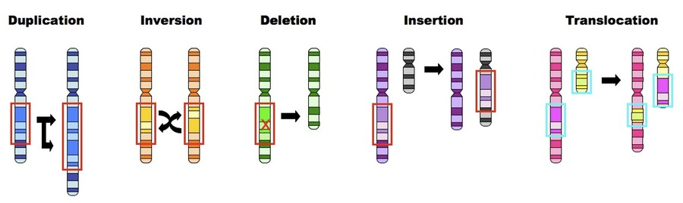Causes of Mutations
Many mutations are not caused by errors in replication. Mutations can happen spontaneously, and they can be caused by mutagens in the environment. Some chemicals, such as those found in tobacco smoke, can be mutagens. Sometimes mutagens can also cause cancer. Tobacco smoke, for example, is often linked to lung cancer.
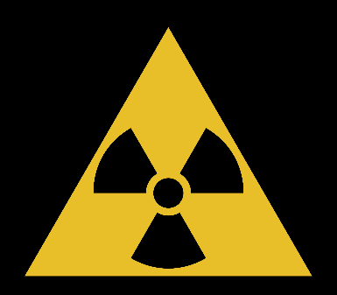
Some types of radiation, chemicals, metals, bacteria, viruses, and ultraviolet rays from the sun can all possibly damage thousands of nucleotides in each of our cells every day. They affect the nucleotides themselves: converting one base to another, knocking a base off its backbone, or even causing a break in the DNA strand.

DNA Repair
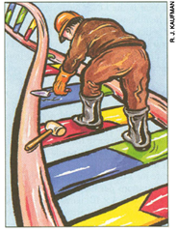
Most of the time, mutation is reversed. DNA repair machines are constantly at work in our cells, fixing mismatched nucleotides and putting broken DNA strands back together. Yet some DNA changes remain. If a cell accumulates too many changes—if its DNA is so damaged that repair machinery cannot fix it—it either stops dividing or it self-destructs. If any of these processes go wrong, the cell could become cancerous.
When we put on sun screen, we are protecting ourselves against mutation in somatic cells—the cells that make up the body and are not involved in reproduction.​ Only when DNA changes are carried in egg and sperm cells are they passed to the next generation. Believe it or not, a certain amount of sloppiness is built into the system. Without mutation there would be no variation, and without variation there would be no evolution.
It’s important to remember that losing the function of a gene doesn’t always affect health. For example, most mammals have hundreds of genes that code for olfactory receptors (gives us the ability to smell). Losing one of these genes probably doesn’t make all that much difference.
In contrast to variations that cause disease, there are many more examples of variations that are neither good nor bad, but just different—like blood types and eye color. Just like with disease alleles, the process of mutation creates these more neutral variations. But with neutral variations, it can be impossible to tell which allele is the "normal" one that existed first and which is the "mutant"—and the distinction is often meaningless.
