Plant Cell Label & Color
Cell Membrane (orange)  Nucleoplasm (yellow)  Mitochondria (red)  Vacuole (lt. Blue)  Chromatin (gray) | Cell Wall (dark green)  Nucleolus (brown)  Chloroplasts (light green) | Ribosome (purple)  Cytoplasm (white)  Golgi Apparatus (dk blue)
Smooth Endoplasmic Reticulum (pink)
Rough Endoplasmic Reticulum (pink)

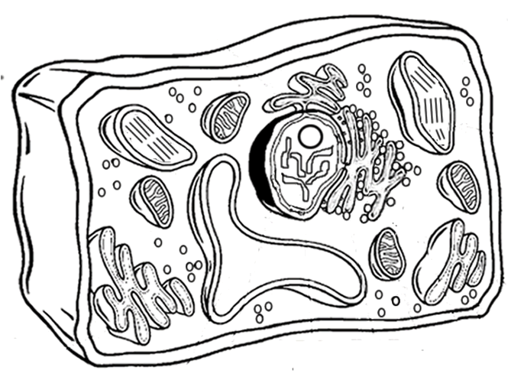
Label each part of the diagram that you color. Remember to use straight lines and no arrows. As a resource, you may use http://www.cellsalive.com/cells/cell_model.htm
Animal Cell Label & Color
Cell Membrane(light brown) | Nucleolus (black) | Mitochondria (orange)
Cytoplasm (light yellow) | Golgi Apparatus (pink) | Lysosome (purple)
Nucleoplasm (pink) | Flagella (red/blue striped) | Ribosome (red)
Microtubules (dark green) | Smooth Endoplasmic Reticulum (light blue)
Nuclear Membrane (dark brown) | Rough Endoplasmic Reticulum (dark blue)
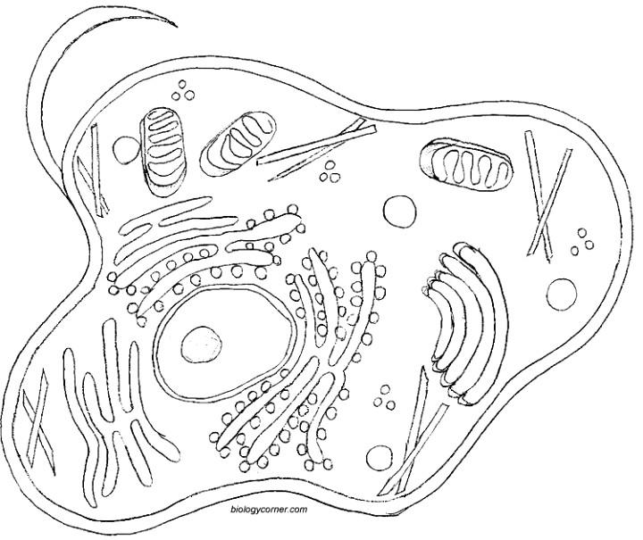
Label each part of the diagram that you color. Remember to use straight lines and no arrows. As a resource, you may use http://www.cellsalive.com/cells/cell_model.htm

