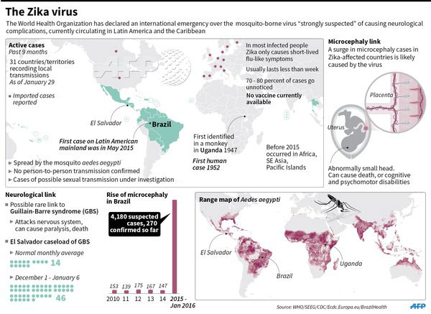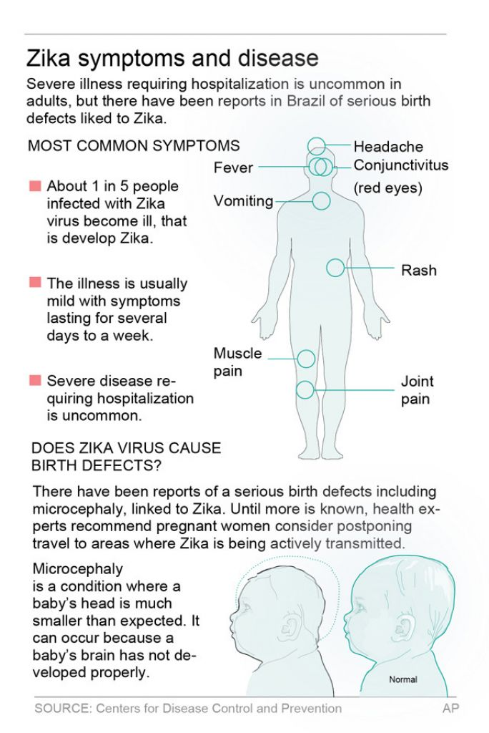

*Answer on a separate sheet.*

1. Based on the map above, where has the Zika virus been most active in the last year?
2. How does one get the Zika virus?
3. On the second map, you can see the areas where the Aedes mosquito can be found, why don’t you think all of those countries are seeing the Zika virus?
4. What symptoms should most people with the Zika virus expect?
5. If the Zika virus has been around since 1947, why has the Zika virus gotten so much attention from the news in the last year? Use evidence from the graphics to answer.
6. What is the major concern for women who are pregnant?
7. What long-term effects could the Zika virus have on someone?
8. If the Zika virus has not reached North Carolina, why should we be concerned? Use evidence and deduction to answer.