Who had it right? – Microscope Edition
In each situation, a pair of students is using microscopes. Look over their techniques and determine which one, if any, are using the proper steps. If a student is making a mistake, underline it in the description. You can earn 1 point for every 2 situations you answer correctly.
 | Student 1 | Student 2 | Who was right?
1. | Justin predicted the object would need the lowest magnification so he lowered the stage to the lowest position before inserting the slide. | Selena predicted that the object would need the highest magnification so she raised the stage to the highest position before inserting the slide.
2. | Harry thought the glass slide would make it difficult to see the specimen, so he put the object directly on the stage to view it. | Liam knew he could move the specimen around under the lens if he put it on a slide first so he put it on a slide before putting it in the microscope.
3. | Once Thor switched the objective lens to high power, he used the coarse adjustment knob to focus. | Once Hulk switched the objective lens to high power, he used the fine adjustment knob to focus.
4. | Snoopy thought the image would be colorless, so he turned the diaphragm to the lowest setting before putting the image in the microscope. | Woodstock thought the image would be dark, so he turned the diaphragm to the highest setting before putting the image in the microscope.
5. | Hermione used the low power (4X) and medium power (10X) to view a specimen. The ocular lens was 10X. To calculate the total magnification she multiplied 4 times 10 times 10 and got 400X. | Ron used the low power (4X) and medium power (10X) to view a specimen. The ocular lens was 10X. To calculate the total magnification, he multiplied 10 times 10 and got 100X.
6. | LeBron suspected that some dust got on the objective lens. He used a paper towel to wipe it away. | Dwayne suspected that some dust got on the objective lens. He used his finger to wipe it away.
7. | Nicki was using the high power objective and the specimen was blurry. She turned the fine adjustment towards her until the slide was touching the objective lens. | Rihanna was using the high power objective lens and the specimen was blurry. She turned the fine adjustment away from her first.
8. | Lefty  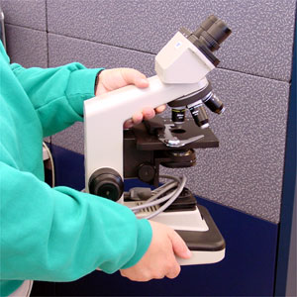 | Righty  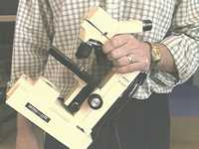

Who had it right? – Microscope Edition
In each situation, a pair of students is using microscopes. Look over their techniques and determine which one, if any, are using the proper steps. If a student is making a mistake, underline it in the description. You can earn 1 point for every 2 situations you answer correctly.
 | Student 1 | Student 2 | Who was right?
1. | Justin predicted the object would need the lowest magnification so he lowered the stage to the lowest position before inserting the slide. | Selena predicted that the object would need the highest magnification so she raised the stage to the highest position before inserting the slide.
2. | Harry thought the glass slide would make it difficult to see the specimen, so he put the object directly on the stage to view it. | Liam knew he could move the specimen around under the lens if he put it on a slide first so he put it on a slide before putting it in the microscope.
3. | Once Thor switched the objective lens to high power, he used the coarse adjustment knob to focus. | Once Hulk switched the objective lens to high power, he used the find adjustment knob to focus.
4. | Snoopy thought the image would be colorless, so he turned the diaphragm to the lowest setting before putting the image in the microscope. | Woodstock thought the image would be dark, so he turned the diaphragm to the highest setting before putting the image in the microscope.
5. | Hermione used the low power (4X) and medium power (10X) to view a specimen. The ocular lens was 10X. To calculate the total magnification she multiplied 4 times 10 times 10 and got 400X. | Ron used the low power (4X) and medium power (10X) to view a specimen. The ocular lens was 10X. To calculate the total magnification, he multiplied 10 times 10 and got 100X.
6. | LeBron suspected that some dust got on the objective lens. He used a paper towel to wipe it away. | Dwayne suspected that some dust got on the objective lens. He used his finger to wipe it away.
7. | Nicki was using the high power objective and the specimen was blurry. She turned the fine adjustment towards her until the slide was touching the objective lens. | Rihanna was using the high power objective lens and the specimen was blurry. She turned the fine adjustment away from her first.
8. | Lefty | Righty

